**Into to Google Photos app**

Google photos can be used from an app downloaded to your device or from the Google Chrome Internet browser. This intro will cover Photos by using Chrome.

Launch Google **Chrome** . Then click or tap the 9 dot cube.

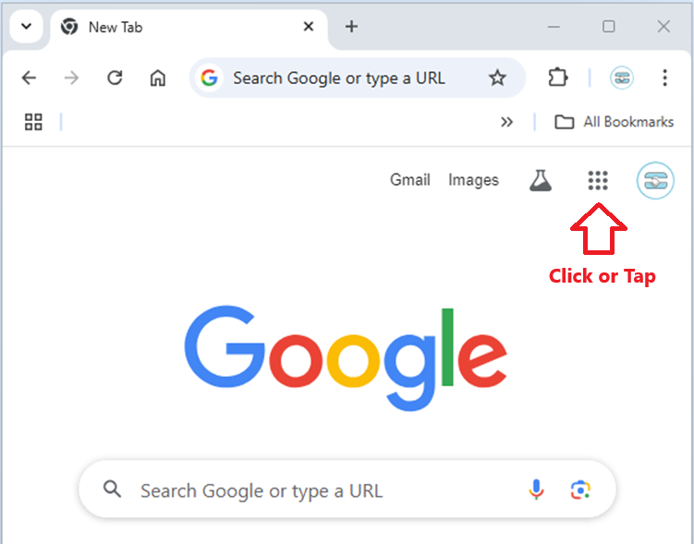

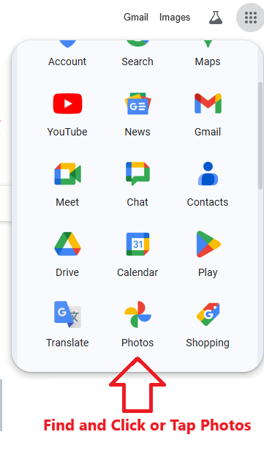

If your browser is not already signed into Google, then this appears

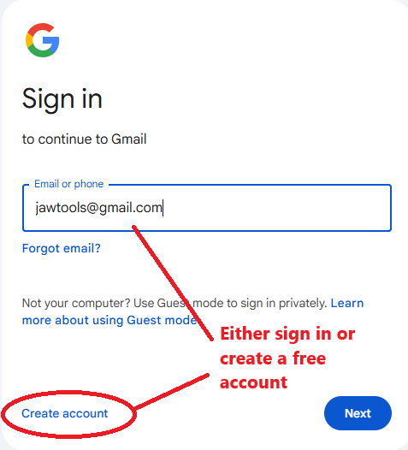

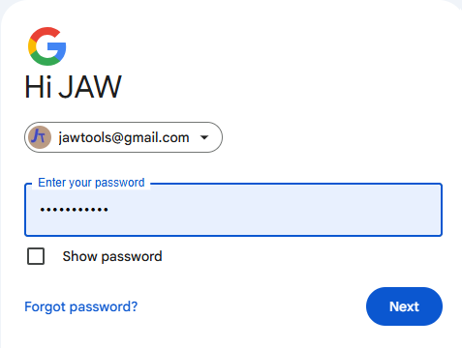

CLICK NEXT on both screens

Drag and Drop

Open MS File explorer (in this example – on Apple use their file manager)

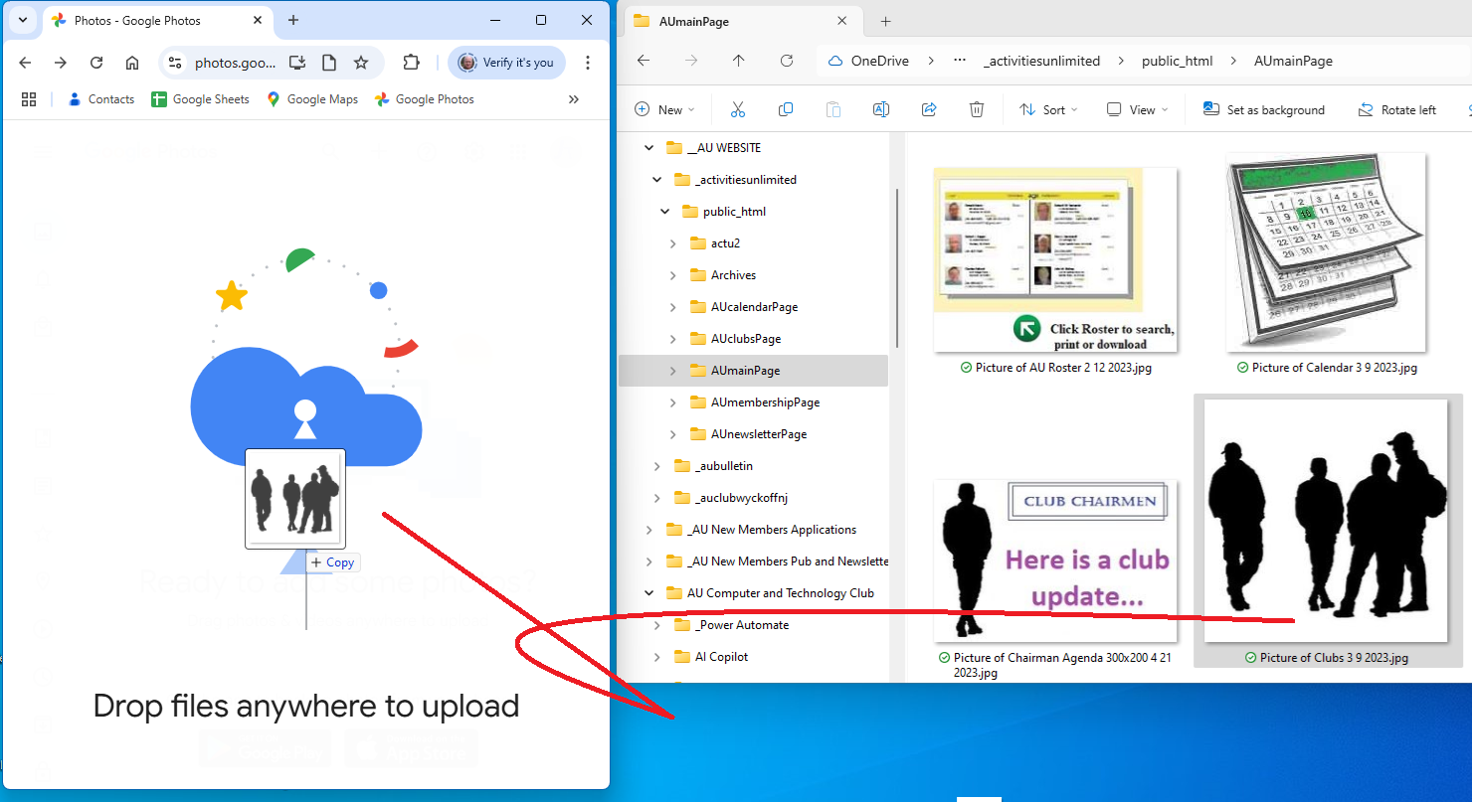

* Left click on the image
* Holding the left click drag to mouse pointer to the “drop files anywhere” window
* Release the mouse click

NOTE: in this exercise “Original quality” is checked when asked for

